D24DCS155

Practical-1

**Aim:** Implement Linear Search and Binary Search using an array data structure.

**Supplementary Experiment:**

**Implement Ternary Search Algorithm**. It is a search algorithm that is used to find the position of a target value within a sorted array. It operates on the principle of dividing the array into three parts instead of two, as in binary search.

**Program (in Python):**

**arr = [22, 33, 44, 55, 66, 77, 88, 99]**

**def lsearch(array, x):**

**for i in range(len(array)):**

**if array[i] == x:**

**print("Element Found")**

**return**

**print("Element not Found")**

**lsearch(arr,44)**

**def bsearch(array, x):**

**l = 0**

**r = len(array) - 1**

**while l <= r:**

**mid = l + (r - l) // 2**

**if array[mid] == x:**

**print("Element Found")**

**return**

**elif array[mid] < x:**

**l = mid + 1**

**else:**

**r = mid - 1**

**print("Element not Found")**

**bsearch(arr,88)**

**Output:**

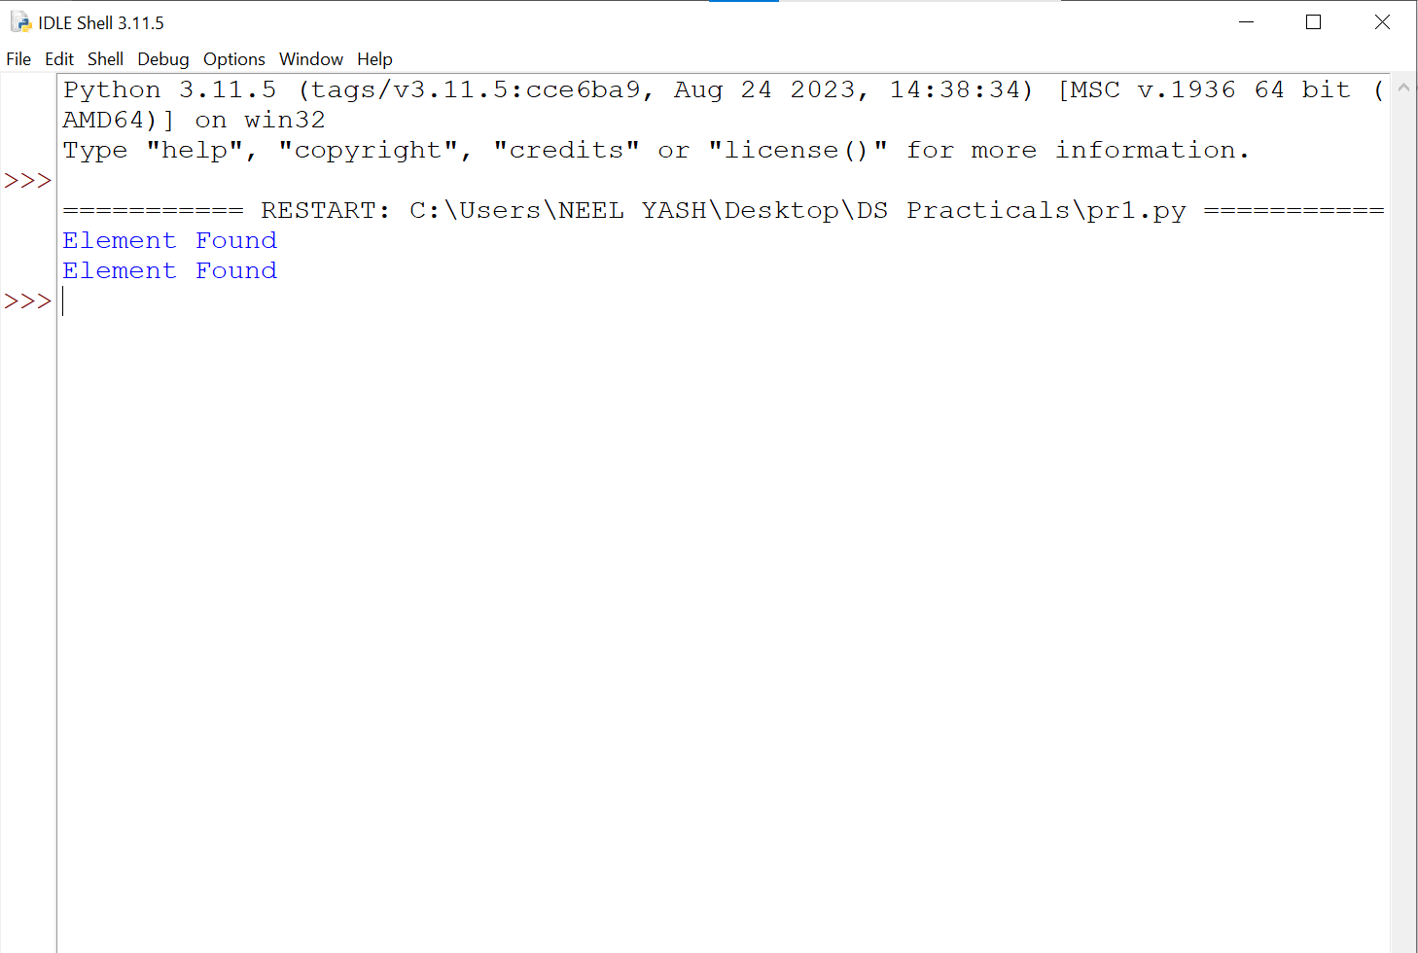

**Fig.1: binary search**

**Conclusion:**

Linear search sequentially checks each element in an array until the target value is found or the end of the array is reached.

Binary search, on the other hand, requires the array to be sorted and repeatedly divides the search interval in half to efficiently locate the target value.